Project Report Template for “Fresh Bites Catering”

1. INTRODUCTION

1.1 Overview

1.2 Purpose

2. PROBLEM DEFINITION & DESIGN THINKING

2.1 Empathy Map

2.2 Ideation & Brainstorming Map

3. RESULT Final

4. ADVANTAGES & DISADVANTAGES

5. APPLICATIONS

6 . CONCLUSION

7 . FUTURE SCOPE

8. APPENDIX

A. Source Code

# INTRODUCTION

## 1.1 Overview

* Fresh Bite Catering specialize in providing catering for a variety of occasions, including breakfast, lunch, dinner, and snacks, as well as reception and cocktail service. No matter what type of event you're hosting, we have the expertise and resources to make it a success.
* This project is using by Zoho in accounting and financing.
* With the help of zohobooks of accounts we create profit and loss account and balance sheet and GST (18%). Calculate for the Fresh Bites Catering.

## Purpose

* Fresh Bite Catering cater for schools, colleges and universities. We serve a wide selection of food and beverages, whilst keeping in mind the nutritional needs of students by offering a range of healthy meal plans. But we don't just serve any food – we also prioritize the nutritional needs of students.
* It is create for the purpose of prepare profit and loss account, balance sheet and prepare GST report for the Fresh Bites Catering.

## Preparation and Maintanence of ZOHO Books for Fresh Bites Catering

Fresh Bites Catering, a catering service, utilizes Zoho Books to manage their sales, track inventory, and handle invoicing. They can generate professional invoices for clients and track expenses related to ingredients and supplies. Zoho Books helps them maintain accurate financial records and streamline their catering operations

# 2. PROBLEM DEFINITION & DESIGN THINKING

* It create method of preparation of accounting profit and loss account, balance sheet and GST calculation is complicated.
* It recent day’s new technologies allotted. Here we use Zohobook as a tool for creating profit and loss account, balance sheet and GST report.

## 2.1 Empathy Map

* An empathy map is a collaborative tool teams can use to gain a deeper insight into their customers. Much like a user persona, an empathy map can represent a group of users, such as a customer segment.
* Empathy Maps are a simple yet powerful tool that can help product managers to better understand their customers' needs and pain points. Empathy Maps are essentially a visual representation of the customers' thoughts, feelings, and behaviors.

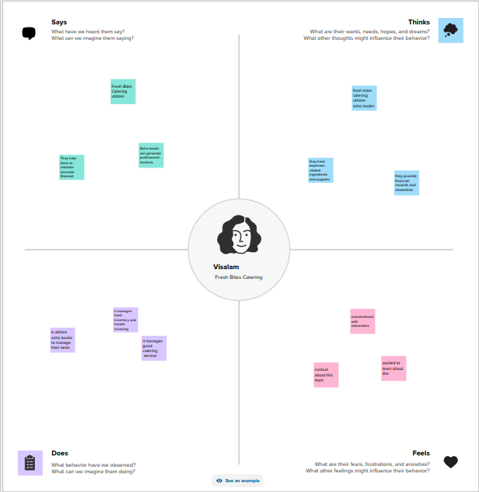

## 2.2 Ideation & Brainstorming Map

* Brainstorming is a group creativity technique by which efforts are made to find a conclusion for a specific problem by gathering a list of ideas spontaneously contributed by its members.

What is brainstorming explain?

* Brainstorming is a group problem-solving method that involves the spontaneous contribution of creative ideas and solutions.

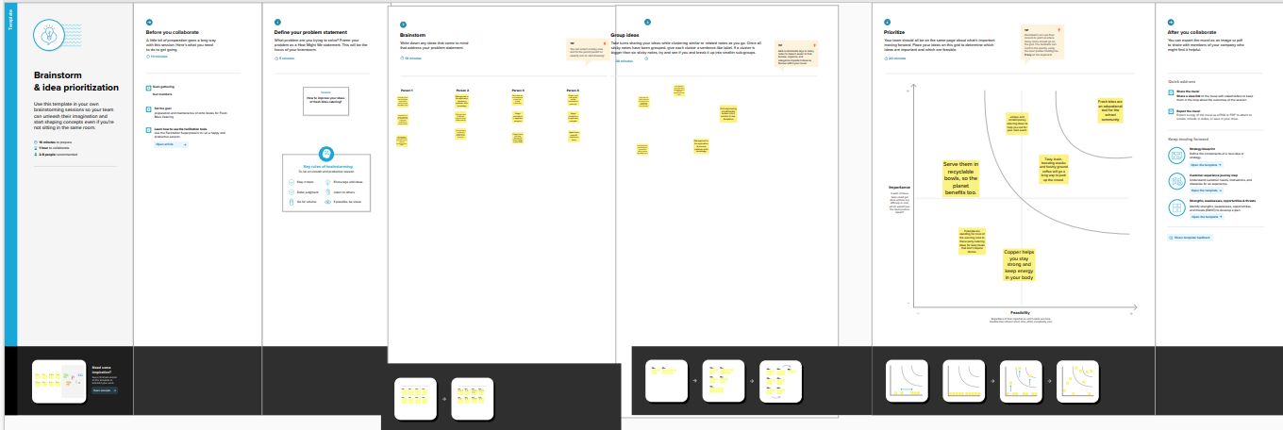

# RESULT

